**JAVA PROGRAMMING**

**DIGITAL ASSIGNMENT-2**

SHASHWAT KUMAR

17BCE1059

Question – 1:

/*

* To change this license header, choose License Headers in Project Properties.

* To change this template file, choose Tools | Templates

* and open the template in the editor.

*/

package javafxapplication1;

import javafx.application.Application;

import javafx.event.ActionEvent;

import javafx.event.EventHandler;

import javafx.scene.Scene;

import javafx.scene.control.ScrollPane;

import javafx.scene.control.Button;

import javafx.scene.layout.FlowPane;

import javafx.stage.Stage;

import javafx.scene.text.Text;

import javafx.geometry.Orientation;

import javafx.scene.control.ScrollPane.ScrollBarPolicy;

import javafx.scene.image.Image;

import javafx.scene.control.Label;

import javafx.scene.control.ScrollBar;

import javafx.scene.image.ImageView;

import javafx.stage.Popup;

/**

*

* @author Priyam

*/

public class JavaFXApplication1 extends Application {

@Override

public void start(Stage primaryStage) {

FlowPane root = new FlowPane();

ScrollPane scrollPane = new ScrollPane();

Scene scene = new Scene(scrollPane, 400, 500);

Label label1 = new Label("Blog By Shashwat Kumar 17BCE1059 \n");

label1.setStyle("-fx-font-weight: bold");

Button button = new Button();

button.setText("Get Author Name");

Image image = new Image("https://i.imgur.com/4YZzRm2.jpg");

// simple displays ImageView the image as is

ImageView iv1 = new ImageView();

iv1.setImage(image);

iv1.setFitWidth(400);

iv1.setFitHeight(200);

iv1.setPreserveRatio(true);

iv1.setSmooth(true);

iv1.setCache(true);

Text text = new Text(“Hailing from a working class family, I am Shashwat. I am a simple and confident fellow. Hard work, time management, sincerity with work and dedication to purpose have been ingrained in my nature./n”+

“I am the students in Vellore Institute of Technology, Chennai, where I’m pursuing Bachelor of Technology in Computer Science. Currently I’m in my 3rd year of course. I intend to take a placement in a good and renowned company with a decent package. After taking a few years of job experience, I am willing to go for higher studies. Fields like machine learning, robotics, data analytics and network securities interests me. /n”+

“It is one of the best engineering colleges in our entire vicinity. We are truly cared, rightly educated and well socialized here at our college. I feel proud of myself being a student here. I do take care of what is being taught and what is to learn. I respect my teachers, my fellow beings and everything that is associated with my college. /n”+

“My father is a renowned professor who knows how to love his profession with passion and dedication. While my mother is a hardworking house maker. That’s I have learned, from the very start, the importance of passion, dedication, confidence and time management. We are two siblings, me and my sister among our parents and my grandmother. My family is what my parents had worked for, i.e. completely happy and satisfied one. I am the youngest of in the family. My elder sister is just four years elder in age than me. /n”+

“ I am a good student, who actively participates in all many activities, be it exams or extra curricular activities. I had been a part of varios clubs, student chapters and had been the core team member of technical and cultural fests in my college. /n”+

“I have been a part of a Social Entrepreneurship club –ENACTUS, since my 1st year. I always had a knack for social work in and around me. I was a part of the Debate Society in my college. I had organised the IntraMUN – 2019. I was a part of the design team of the Qubit-School of computing science and Engineering in TechnoVit. I was a part of the technical team in Vibrance-2019- the annual cultural fest of VIT Chennai. /n”+

“Truly it is said, one cannot study from the books alone. Instead, one has to learn from all extracurricular activities in which one participates. Career planning is the very thing that irritates oneself. Without a sound career planning, right from the start, one cannot stay on the right track. One has to do the things or set the goals in accordance to his or her broad career goals. /n”+

“A man without a sound career planing is like a ship without the radar. It drifts and ultimately sinks down in the deep. I myself want to be a Civil servant to serve my people in my best capacity. I am very much inspired from my maternal uncle who is the chief of police force. That truly inspires me so as I myself want to serve my nation by being a good civil servant. /n”+

“One’s future can be determined by what one has achieved today or what one is doing today. A man who dreams only for future and does nothing for tomorrow can be best named as lazy and pathetic. In that way, I dislike myself being called as a man without a vision and castle maker in sky. /n”+

“I do work for what I dream. So far, I have hard in all fields like in academic, extracurricular and in personal domains. All of this success, hard work, dedication, determination is truly credited to my parents who have made this possible for me. Successes and failures are closely associated with one’s achievements and losses. One who achieves anything today has lost a thing yesterday. There is no completely successful man without the mixture of both failures and successes. That is to say, I failed a dozen of times. But, every failure made me stronger ever. /n”+

“My family, especially my mother, has been the much source of encouragement and motivation for me. That is why I myself am a truly self-inspired, strengthened and dedicated fellow today. I have learnt a lot from my mistakes and from my failures. I never regard my failure as a curse rather an opportunity to improve and to improvise. /n”+

“What I myself regard life is a total pot of opportunities. One has to harness one’s skills and abilities to the maximum of one’s capacity. For every problem there is a solution. I regard the life as a blessing gift to humanity. One should strive hard to improve not only his lot but for his fellow beings. The service of humanity is the best of all services. What I have learnt myself from my experience and struggles is that one should never cease working hard, be confident, positive and adoptable to all situations. The biggest success is that one becomes invincible. Only then, one can face the life in a full vigor and fullest of confidence. /n”+

“Therefore, writing about myself, I’m here to express myself that what I see, what I experience and what I plan for my life is the total manifestation of what I do today. I try myself to be humble, passionate, dedicated, hardworking and honest. I deem my parents as being my best mentors. I have learnt the real meaning and worth of life from my parents. I am with a happy, focused and hardworking family. That is definitely the greatest blessing of God for me.”

+

"");

text.wrappingWidthProperty().bind(scene.widthProperty());

scrollPane.setFitToWidth(true);

scrollPane.setHbarPolicy(ScrollBarPolicy.ALWAYS);

scrollPane.setVbarPolicy(ScrollBarPolicy.ALWAYS);

//scrollPane.setContent(s);

Label label = new Label("Shashwat Kumar");

// create a popup

Popup popup = new Popup();

// set background

label.setStyle(" -fx-background-color: white;");

// add the label

popup.getContent().add(label);

// set size of label

label.setMinWidth(80);

label.setMinHeight(50);

// action event

EventHandler<ActionEvent> event =

new EventHandler<ActionEvent>() {

public void handle(ActionEvent e)

{

if (!popup.isShowing())

popup.show(primaryStage);

else

popup.hide();

}

};

// when button is pressed

button.setOnAction(event);

root.getChildren().add(label1);

root.getChildren().add(iv1);

root.getChildren().add(text);

root.getChildren().add(button);

scrollPane.setContent(root);

primaryStage.setTitle("Hello World!");

primaryStage.setScene(scene);

primaryStage.show();

}

/**

* @param args the command line arguments

*/

public static void main(String[] args) {

launch(args);

}

}

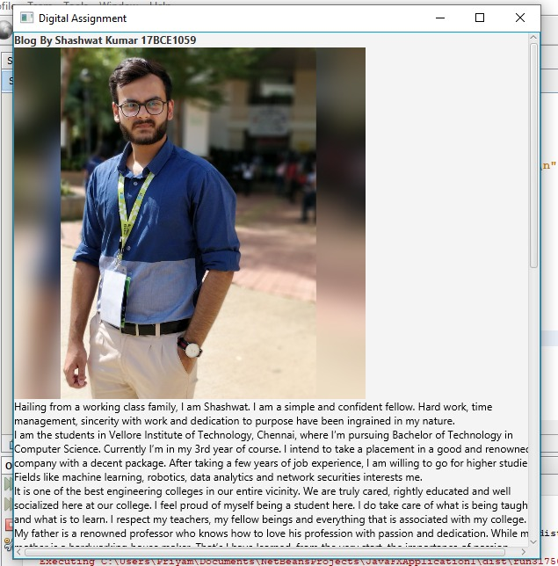

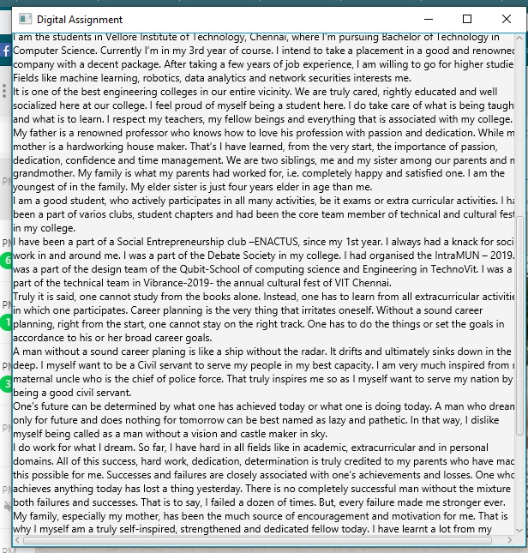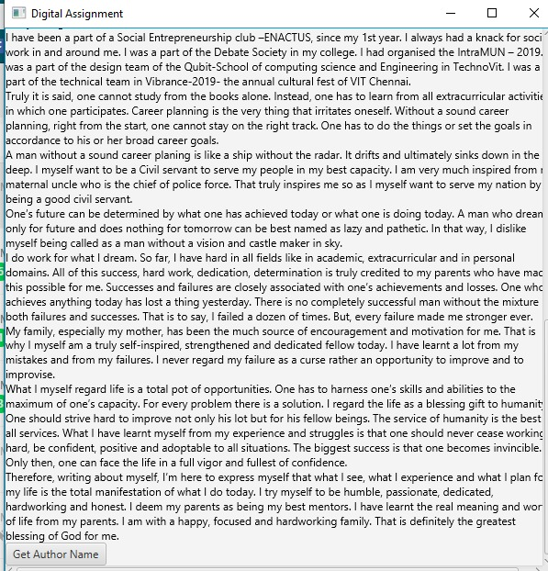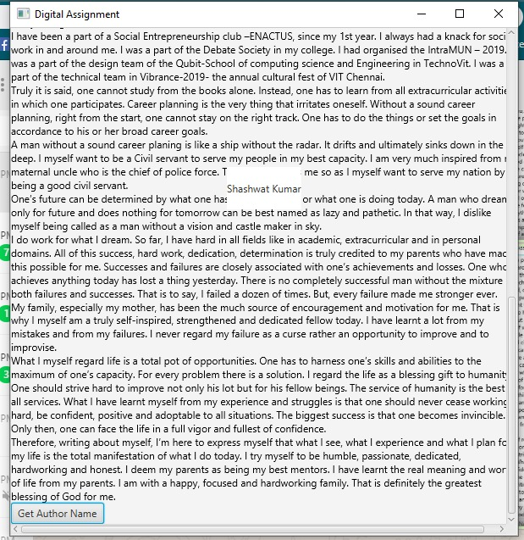

Question – 2:

Java 8 Features

Some of the important Java 8 features are;

1. forEach() method in Iterable interface
2. default and static methods in Interfaces
3. Functional Interfaces and Lambda Expressions
4. Java Stream API for Bulk Data Operations on Collections
5. Java Time API
6. Collection API improvements
7. Concurrency API improvements
8. Java IO improvements
9. Miscellaneous Core API improvements